Report Assignment 1: Training a Neural Network to Estimate the Decay Coefficients of a Gas Turbine
Author: Simone Magistrali
Email: smi25011@student.mdu.se
Course: Learning Systems DVA493
Professor: Ning Xiong
Semester: Fall 2025

1. Introduction and Objective
The goal of this report is to describe the implementation and training of an artificial neural network (ANN) for a regression problem. The task, as specified in Assignment 1, is to predict the two decay coefficients (one for the compressor and one for the turbine) based on 16 features describing the physical state of a gas turbine.
The dataset used is the "maintenance" dataset, which consists of 11934 examples generated by a sophisticated simulator.

2. Data preparation
To prepare the data for training, the following steps were performed.

2.1. Data Division
As required by the specification, the complete dataset was split into three distinct subsets using the train_test_split function of the scikit-learn library. A RANDOM_STATE = 45 has been set to ensure the reproducibility of the experiments.
The data was split into Training Set, Validation Set and Test Set with the following percentages: 50%, 25% and 25%.
The Training Set is used to train the neural network, the Validation Set to evaluate the error at each epoch and finally the Test Set to calculate the error at the end of the training process.

2.2. Normalization
To facilitate network learning, the 16 input features X and the 2 output coefficients Y were standardized (Z-score). The mean “mu” and standard deviation “sigma” were calculated only on the training set and then applied to validation and testing to prevent data leakage:
$$Z = \frac{X - mu}{sigma}$$

3. Structure of the Neural Network (ANN)
The chosen architecture is the following:
- Input Layer: 16 neurons (corresponding to the 16 input features).
- Hidden Layer 1: 30 neurons, with Sigmoid activation function.
- Hidden Layer 2: 30 neurons, with Sigmoid activation function.
- Output Layer: 2 neurons (corresponding to the decay coefficients), with Linear activation function (identity).
The network topology can be summarized as: 16-30-30-2.
Hyperparameters used:
- Learning Rate ( $η)$: 0.01
- Maximum epoch: 15000

4. Learning Method
The method used to train the network is the Backpropagation algorithm.
The weight update process occurs as follows:
- Forward Pass: The input passes through the network to generate a prediction.
- Calculating the Error Term: Calculate the error term for each layer:
  - output layer:$δ =ExpectedOutput -Output$
  - input/hidden layer:$δ = Output (1- Output) \sum{δw}$
- Backward Pass: The error is propagated backward. For the output layer (linear), the gradient is equal to the error. For hidden layers, the gradient is calculated by multiplying the backpropagated error by the derivative of the sigmoid function: $σ'(x) = σ(x)(1-σ(x))$.
- Update: The weights “W” and biases “b” are updated immediately after every single sample according to the rule:
$$W{new = W{old - ηδX}_{}}_{}$$Where $η$is the learning rate, $δ$is the error term and X is the corresponding input.

5. Validation Accuracy Graph
The following figure shows the evolution of the Mean Squared Error (MSE) for both the training set and the validation set during the training epochs.
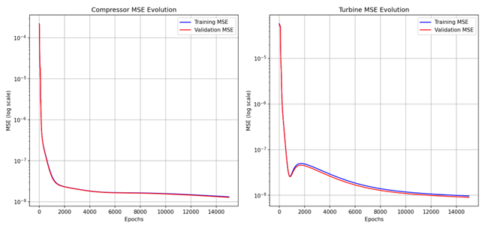
The graph shows two descending (logarithmic) curves, demonstrating a correct learning process for the network. The lack of significant divergence between the training and validation curves suggests the absence of overfitting.

6. Prediction Accuracy on the Test Set
The final performance of the model was evaluated on the test set (data never seen during training). The results were denormalized to be compared with the original requirements.
Requirements:
- MSE Compressor: $5.0 × 10^{-8}$
- MSE Turbine: $1.5 × 10^{-8}$
Results obtained:
- MSE Final (Compressor): $1.3482× 10^{-8}$
- MSE Final (Turbine): $1.0734 × 10^{-8}$
The mean squared error on the tests is below the thresholds for both coefficients. The neural network meets the accuracy requirements.

7. Conclusion
The project demonstrated the effectiveness of a 16-30-30-2 architecture in learning the complex relationship between turbine sensor measurements and their decay coefficients. The use of backpropagation and careful data preprocessing achieved the desired accuracy goals.

